gCentre Number | Candidate Number
Surname
Other Names
Candidate Signature
General Certificate of Secondary Education

Media Studies
48101
Unit 1 Investigating the Media

Insert - Storyboard Sheet
Instructions
- Fill in the boxes at the top of this page.
- Fasten this insert securely to your answer book at the end of the examination.
STORYBOARD SHEET
 | Shot No.1  Graphic of Song Name  ( This City ) | Intro of Song - Sound  Guitar Instrumental intro  Sound of traffic light – non-diegetic sound
Edit/Length of shot: 00:01 – 00:04
 | Shot No.2  Graphic of Artist Name  ( Sam Fischer) | Continue of Intro - Sound  Guitar Instrumental intro
Edit/Length of Shot: 00:04-00:06
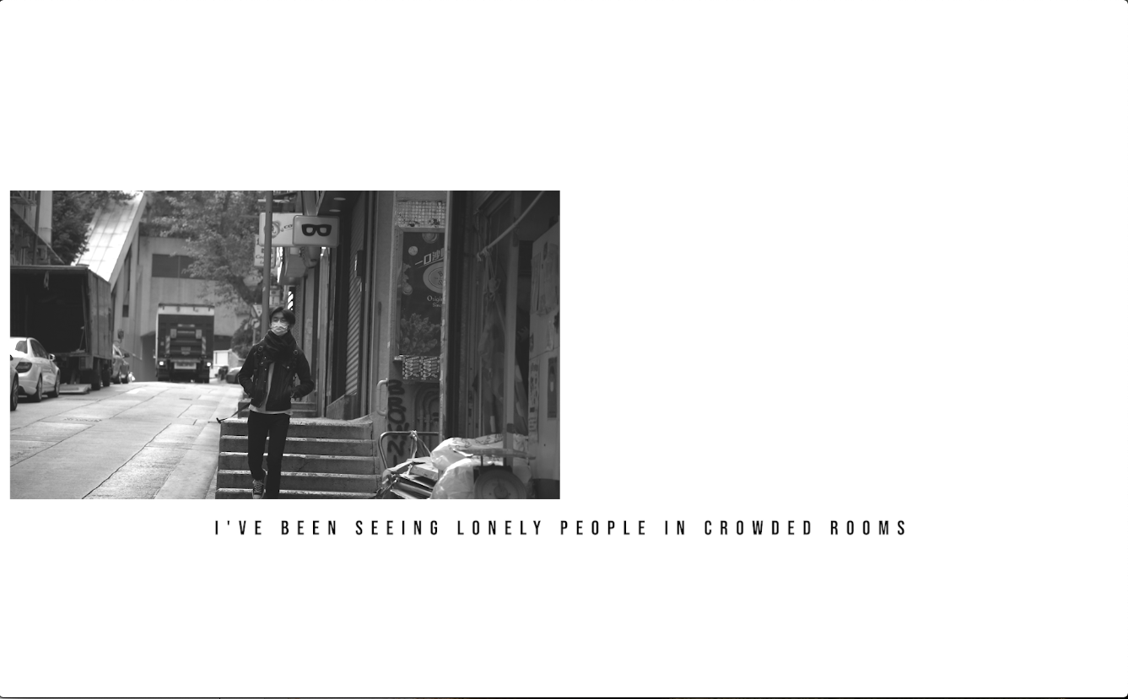 | Shot No.3  Camera Movement :  Still  Type of Shot :  Long shot -> Medium Shot  Brief Description :  Boy walks down the street ( Transition of long shot to medium shot)  Colour :  Black and White | Verse 1– Sound  Guitar Accompaniment  Male Vocal  Lyrics :  I've been seeing lonely people in crowded rooms
Edit/Length of Shot: 00:07- 00:12
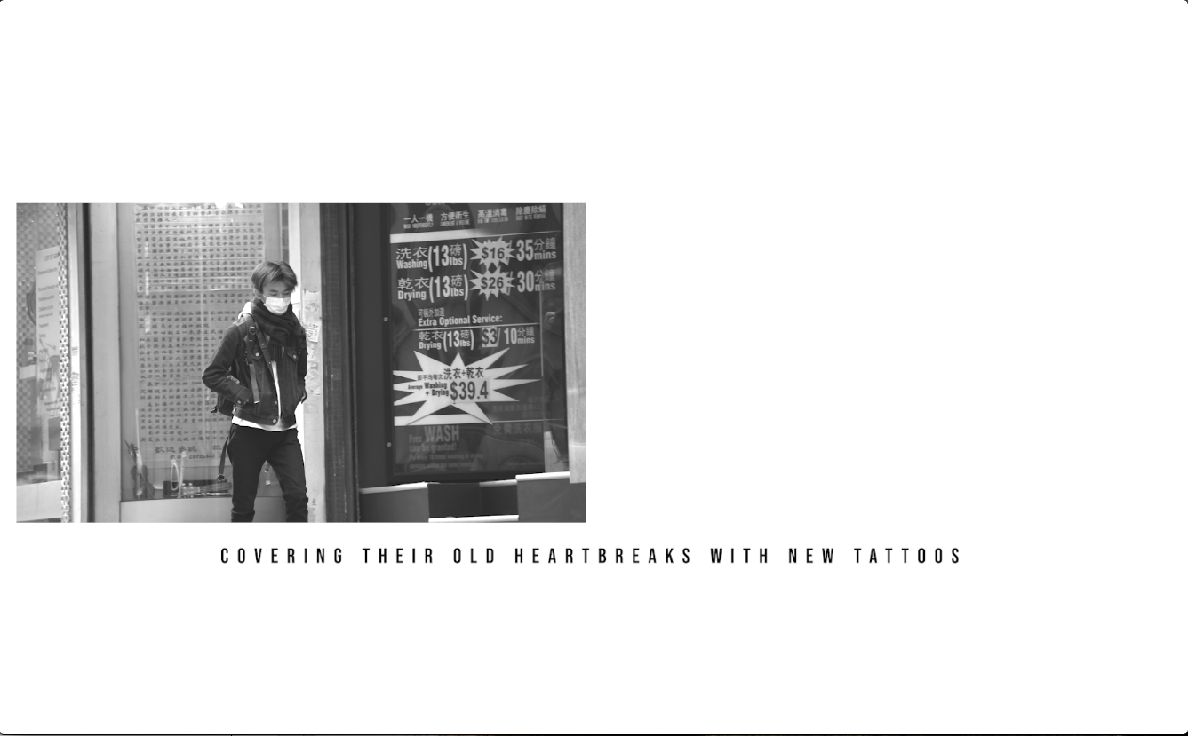 | Shot No.4  Camera Movement :  Tracking  Type of Shot :  Medium/long Shot  Brief Description :  Boy walks down the street ( Side Angle)  Colour :  Black and White | Verse 1– Sound  Guitar Accompaniment  Male Vocal  Lyrics :  Covering their old heartbreaks with new tattoos
Edit/Length of Shot: 00:13-00:19
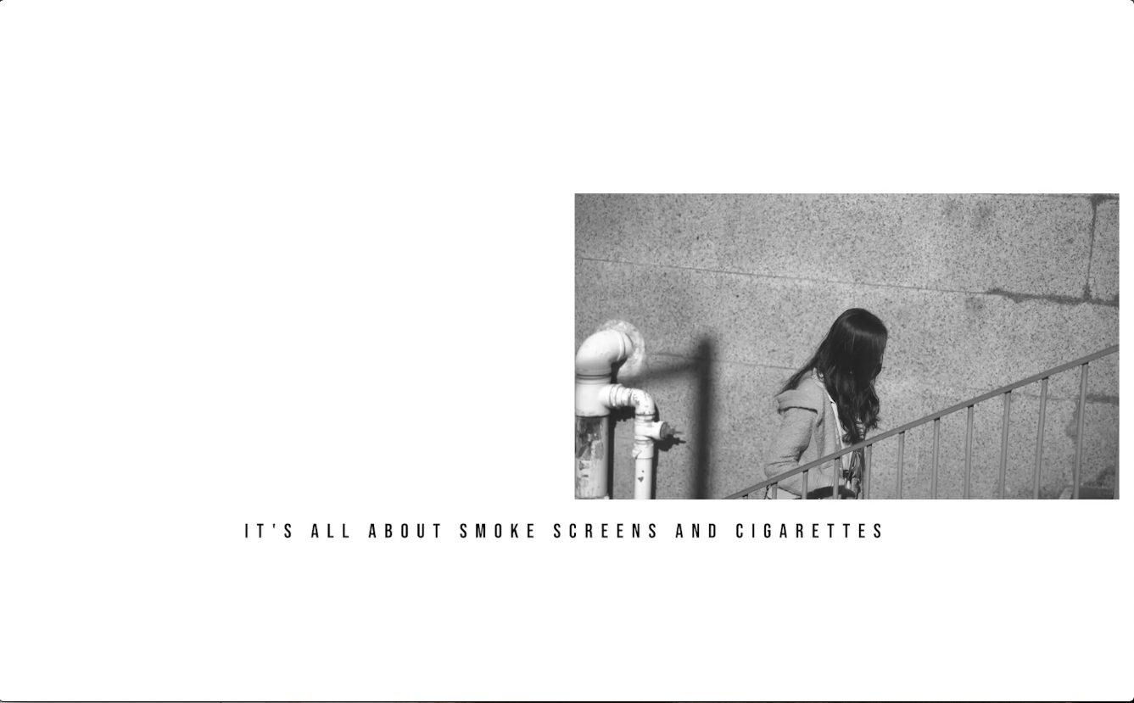 | Shot No.5  Camera Movement :  Tracking  Type of Shot :  High angle - Medium Shot  Brief Description :  Girl walks up the stairs ( Side Angle)  Colour :  Black and White | Verse 1– Sound  Guitar Accompaniment  Male Vocal  Lyrics :  It's all about smoke screens and cigarettes  Looking through low lights at silhouettes
Edit/Length of Shot: 00:20-00:25

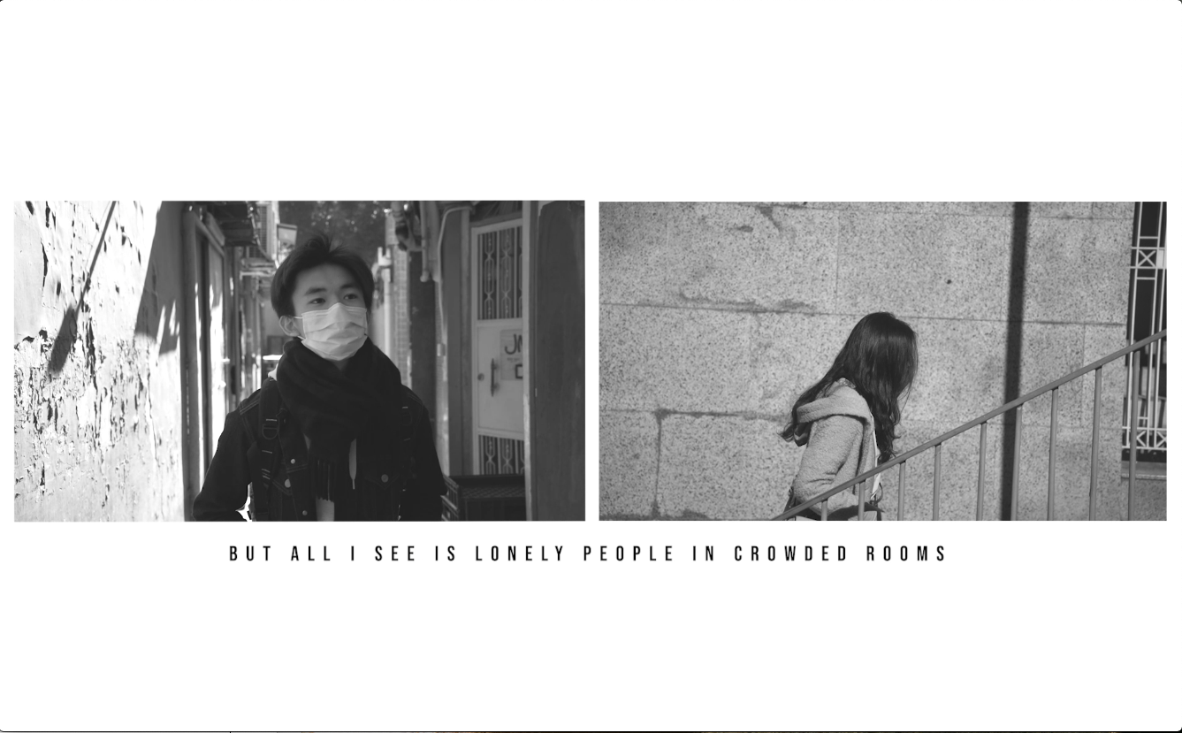 | Shot No. 6  Split Screen  Left Camera Movement :  Dolly Shot  Type of Shot :  Medium Shot  Brief Description :  Boys walk in street lane ( Front Angle)  Girl walks up the stairs  Colour :  Black and White | Verse 1– Sound  Guitar Accompaniment  Male Vocal  Lyrics :  But all I see is lonely people in crowded rooms
Edit/Length of Shot: 00:26 – 00:30
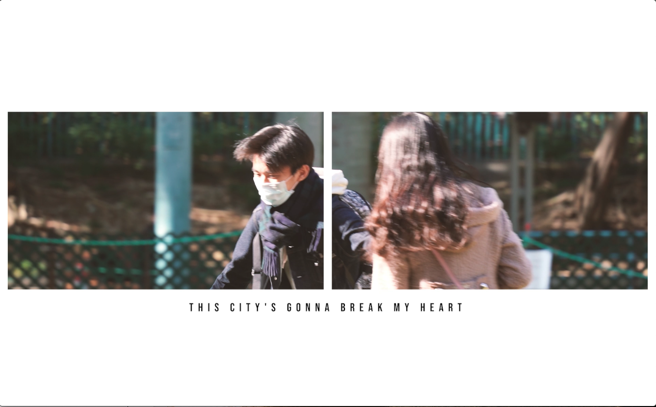 | Shot No. 7  Camera Movement :  Tracking Shot  Type of Shot :  Medium Shot  Brief Description :  Boys and Girl play in the park  Colour :  Colour | Chorus– Sound  Guitar Accompaniment  Male Vocal  Lyrics :  This city's gonna break my heart  This city's gonna love me then leave me alone
Edit/Length of Shot: 00:33 – 00:38
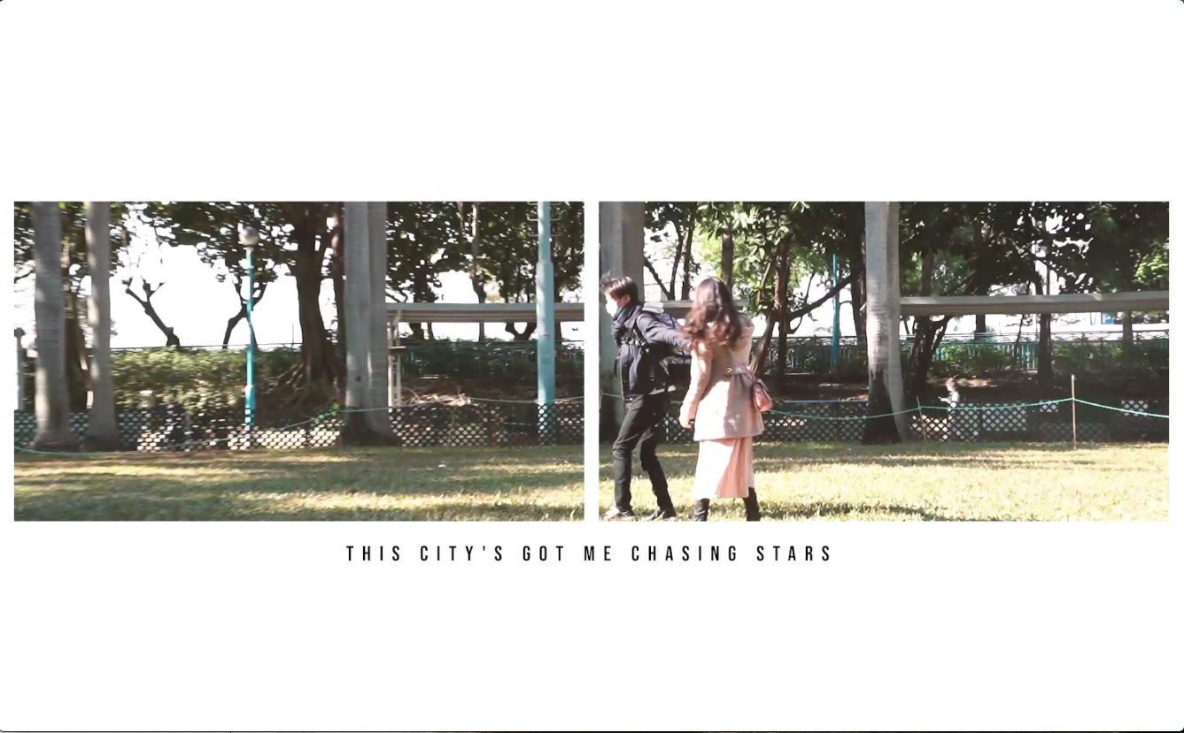 | Shot No. 8  Camera Movement :  Zoom Shot  Type of Shot :  Medium Shot -> Long Shot  Brief Description :  Boys and Girl play in the park  Colour :  Colour | Chorus– Sound  Guitar Accompaniment  Male Vocal  Lyrics :  This city's got me chasing stars  It's been a couple months since I felt like I'm home
Edit/Length of Shot: 00:39 – 00:44
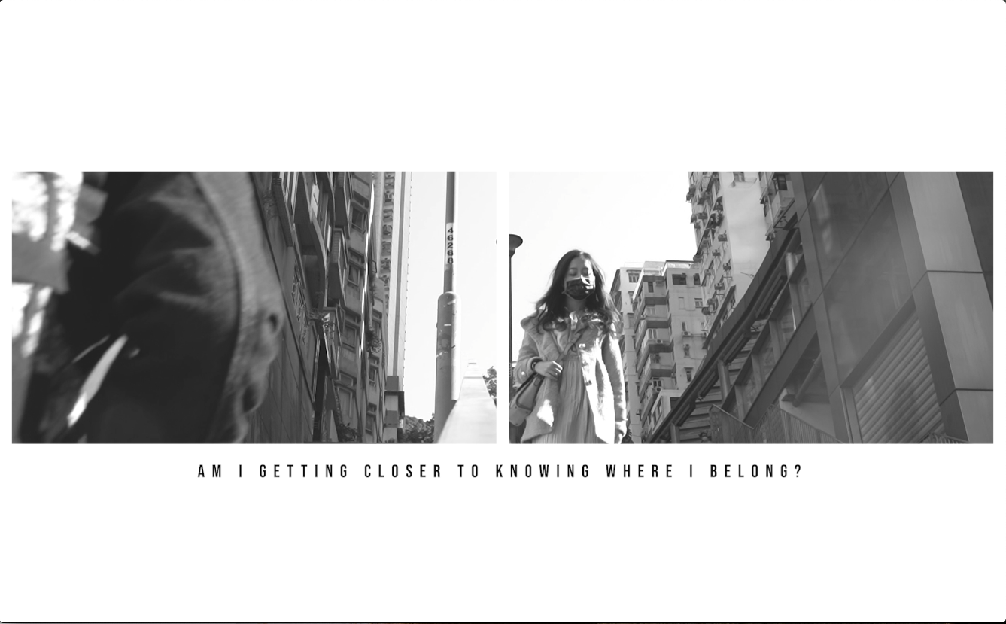 | Shot No. 9  Camera Movement :  Still Shot  Type of Shot :  Low angle - Medium Shot  Brief Description :  Boys walks up the stairs  Girl walks down the stairs  Colour :  Black and white | Chorus– Sound  Guitar Accompaniment  Male Vocal  Lyrics :  Am I getting closer to knowing where I belong?
Edit/Length of Shot: 00:45 – 00:47
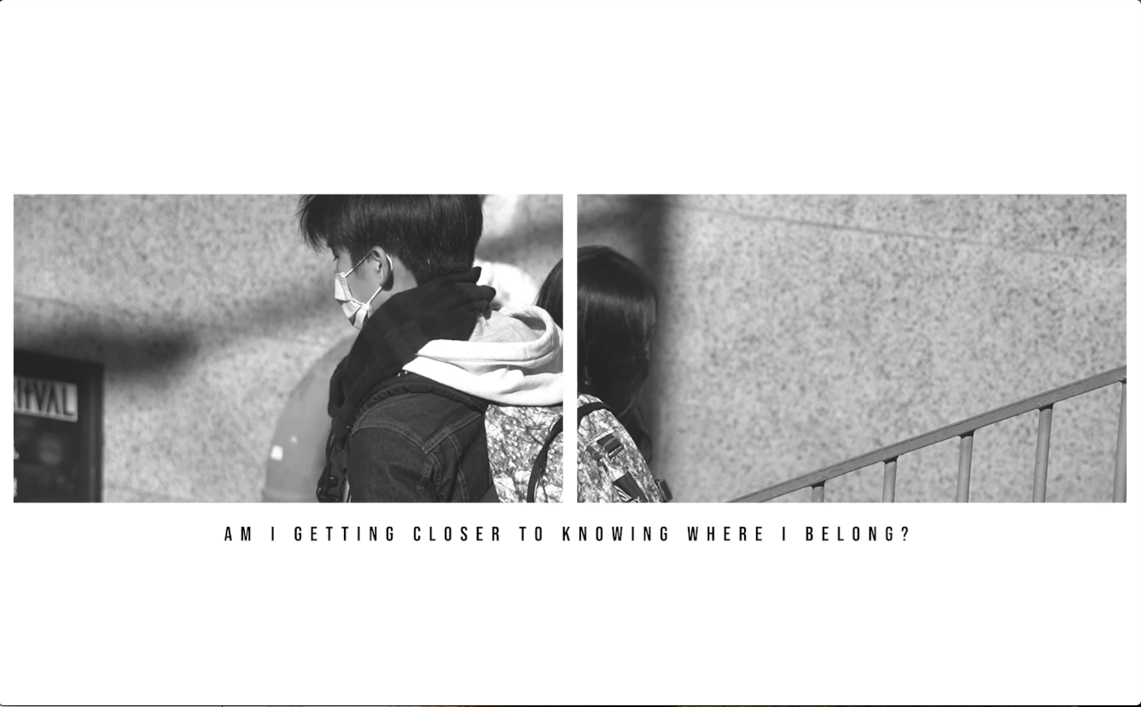 | Shot No. 10  Camera Movement :  Tracking  Type of Shot :  Medium Shot  Brief Description :  Boys walks up the stairs  Girl walks down the stairs  ( side angle)  Colour :  Black and white | Chorus– Sound  Guitar Accompaniment  Male Vocal  Lyrics :  Am I getting closer to knowing where I belong?
Edit/Length of Shot: 00:48 – 00:51

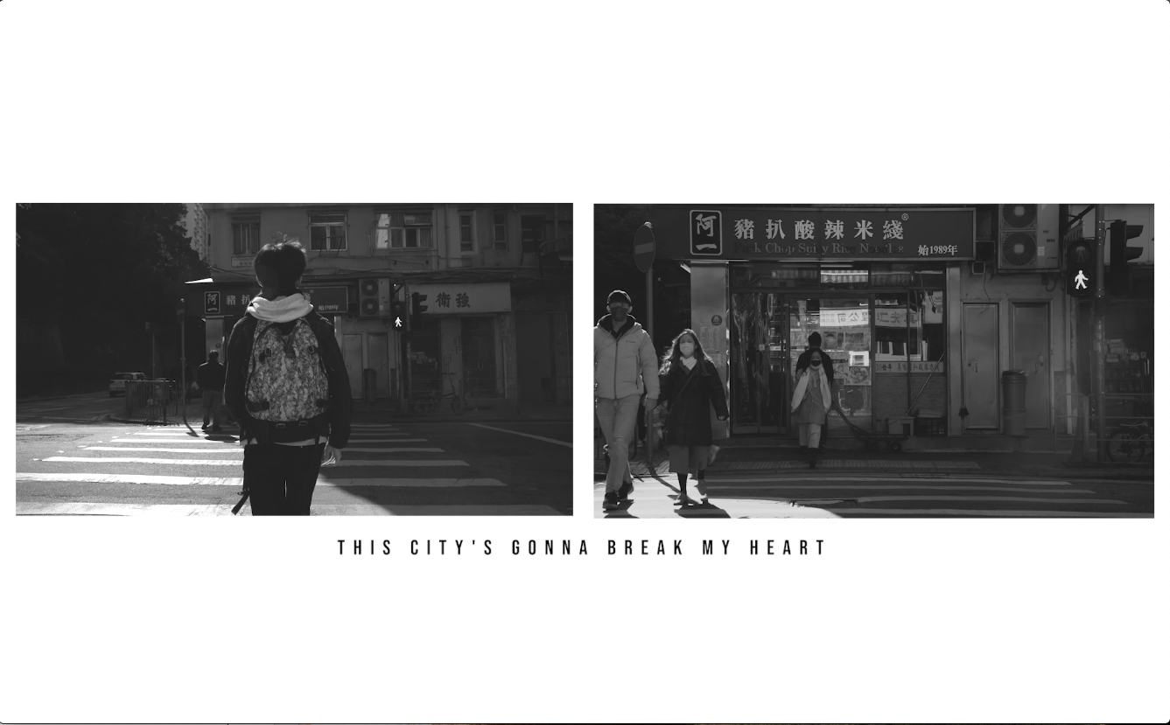 | Shot No. 11  Left Camera Movement :  still Shot  Type of Shot :  Long Shot / medium shot  Brief Description :  Boys walk across the traffic light ( Back Angle)  Girl walk across the traffic light ( Front Angle)  Colour :  Black and White | Chorus– Sound  Guitar Accompaniment  Male Vocal  Lyrics :  This city's gonna break my heart  She's always gonna break your heart, oh
Edit/Length of Shot: 00:52 – 01:04
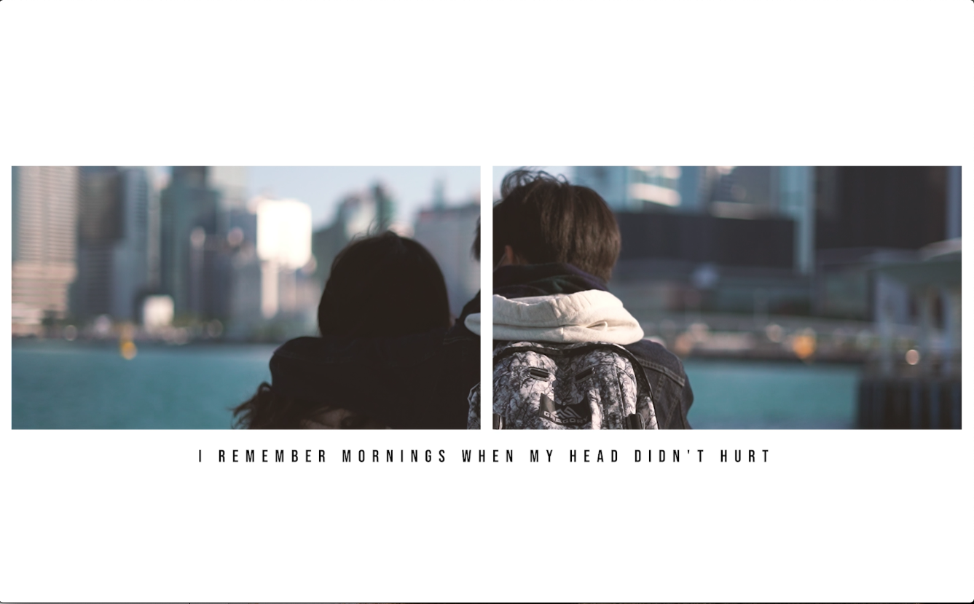 | Shot No. 12  Camera Movement :  Still Shot  Type of Shot :  Medium Shot  Brief Description :  Boys and Girl look at the sea together  Colour :  Colour | Verse 2– Sound  Guitar Accompaniment  Male Vocal  Lyrics :  I remember mornings when my head didn't hurt
Edit/Length of Shot: 01:06 – 01:11
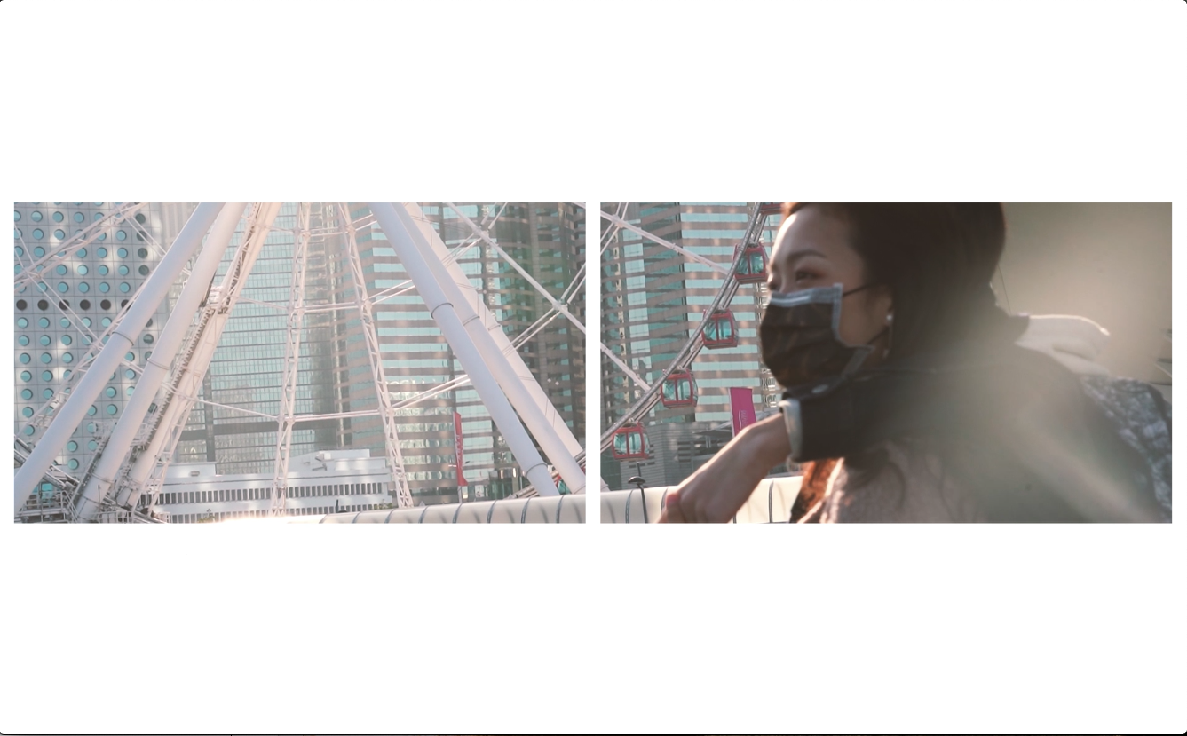 | Shot No. 13  Camera Movement :  Still Shot  Type of Shot :  Close up Shot  Brief Description :  Boys and Girl look at the sea together. (side angle)  Colour :  Colour | Verse 2– Sound  Guitar Accompaniment  Male Vocal  Lyrics :  And I remember nights when art didn't feel like work
Edit/Length of Shot: 01:12 – 01:17
P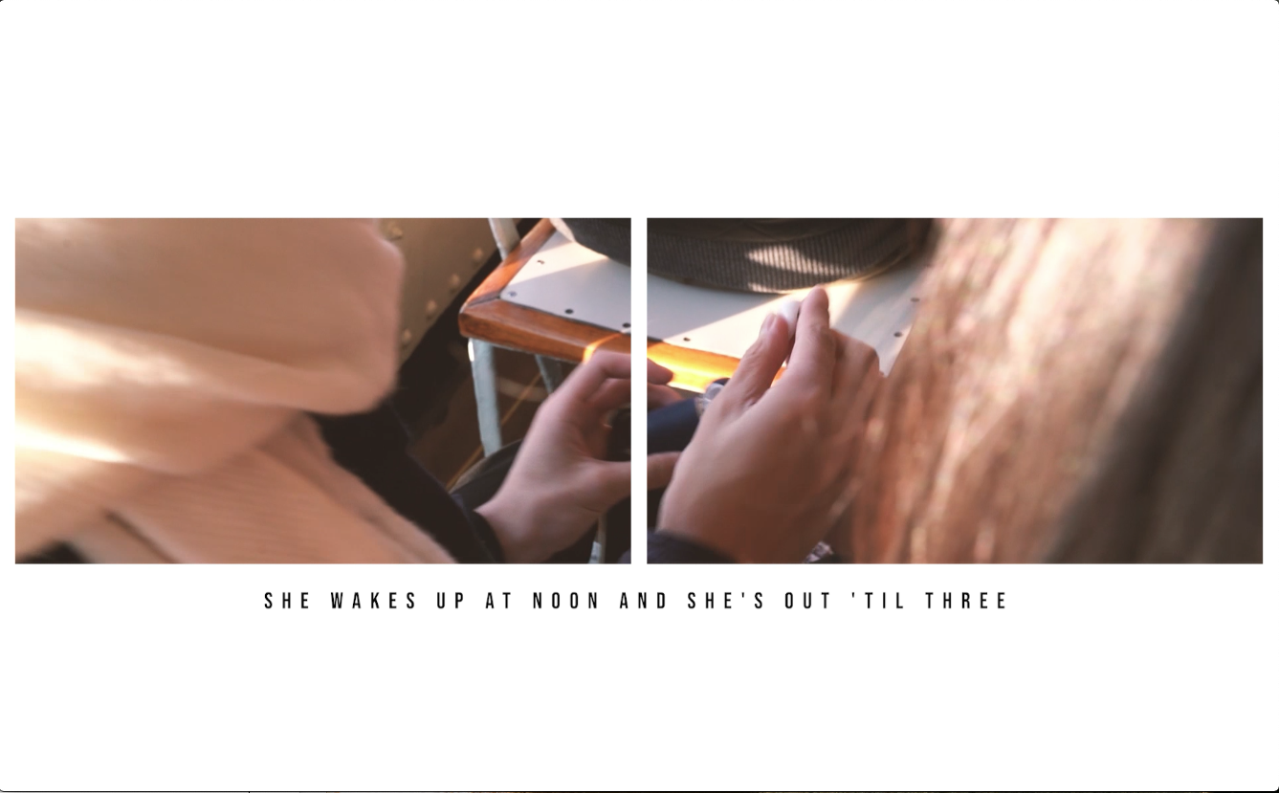 | Shot No. 14  Camera Movement :  Still Shot  Type of Shot :  POV shot  Brief Description :  Boys takes out earphone and share with girl  Colour :  Colour | Verse 2– Sound  Guitar Accompaniment  Male Vocal  Lyrics :  She wakes up at noon and she's out 'til three
Edit/Length of Shot: 01:18 – 00:21
C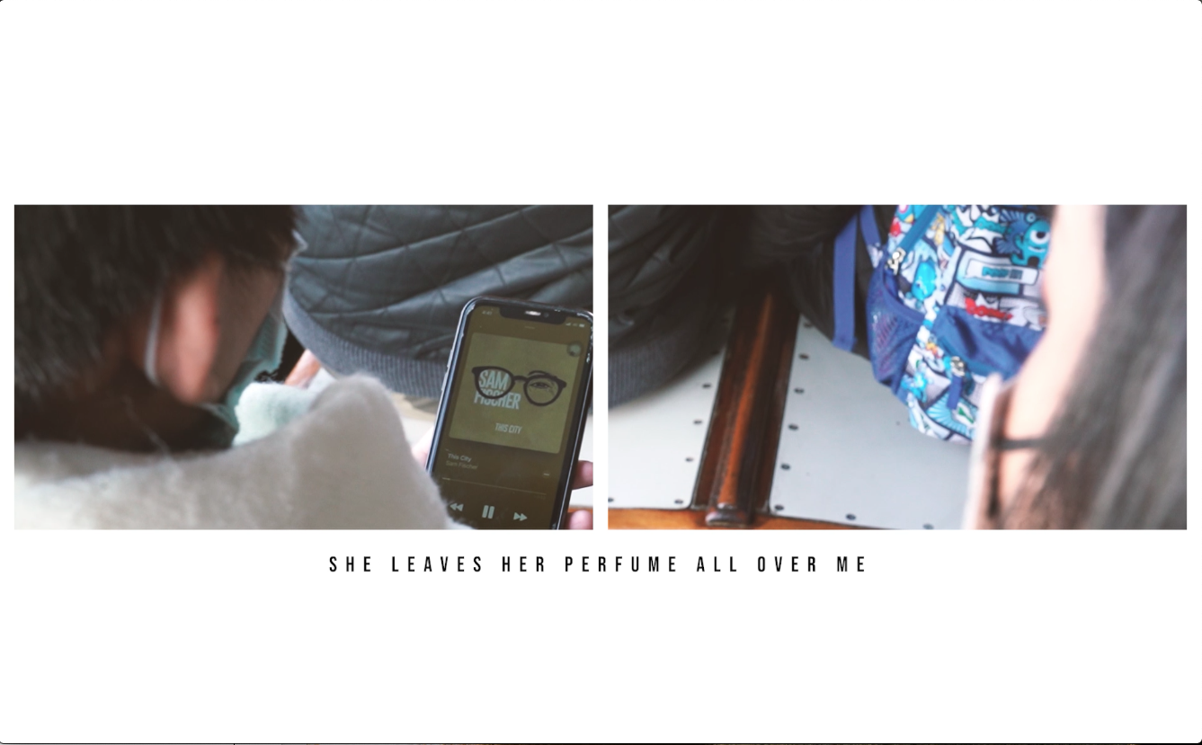 | Shot No. 15  Camera Movement :  Still Shot  Type of Shot :  Medium Shot  Brief Description :  Boy and girl listen to the song “This City”  Colour :  Colour | Verse 2 – Sound  Guitar Accompaniment  Male Vocal  Lyrics :  She leaves her perfume all over me
Edit/Length of Shot: 01:22– 01:24

\

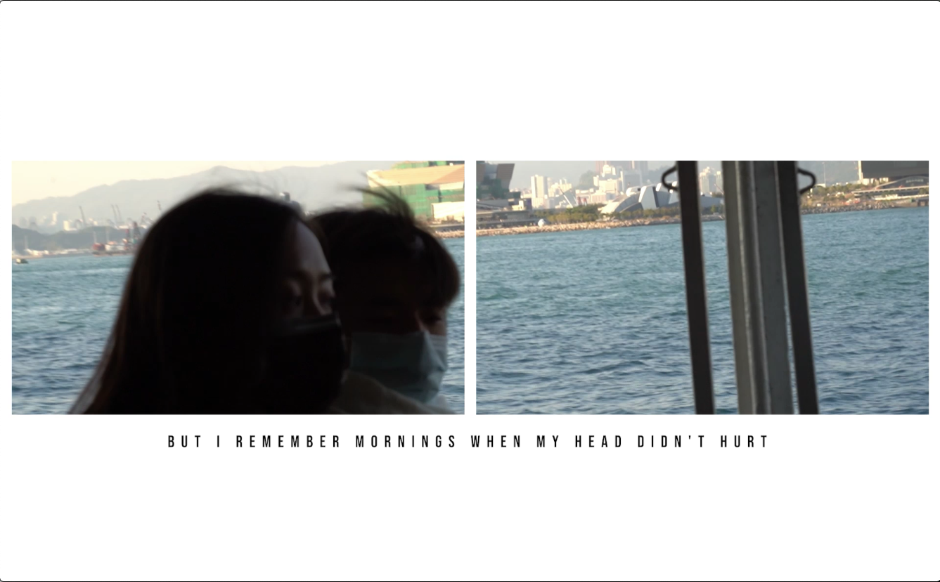 | Shot No. 16  Left Camera Movement :  Still Shot  Type of Shot :  Close up Shot  Brief Description :  Boys and girl sitting together on the ferry  Colour :  Colour | Verse 2– Sound  Guitar Accompaniment  Male Vocal  Lyrics :  But I remember mornings when my head didn't hurt
Edit/Length of Shot: 01:24 – 01:28
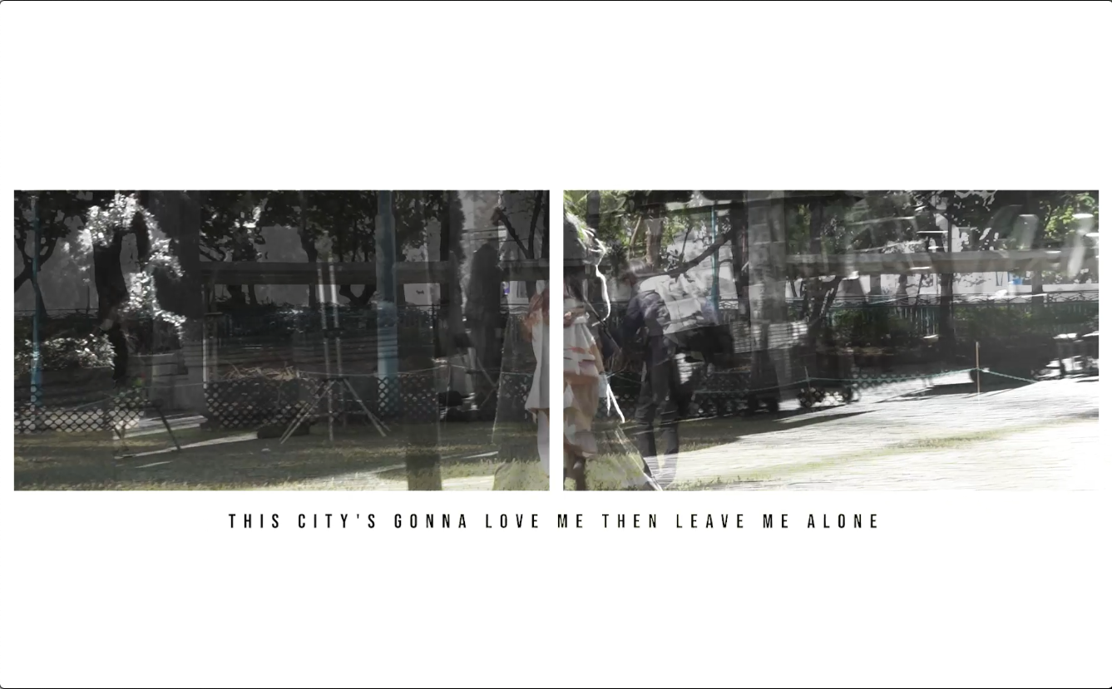 | Shot No. 17  Camera Movement :  Tracking Shot  Type of Shot :  Long Shot / Medium Shot  Brief Description :  Girl walks alone in the city  Colour :  Colour | Chorus – Sound  Guitar Accompaniment  Male Vocal  Lyrics :  Oh, this city's gonna break my heart
Edit/Length of Shot: 01:31 – 01:35
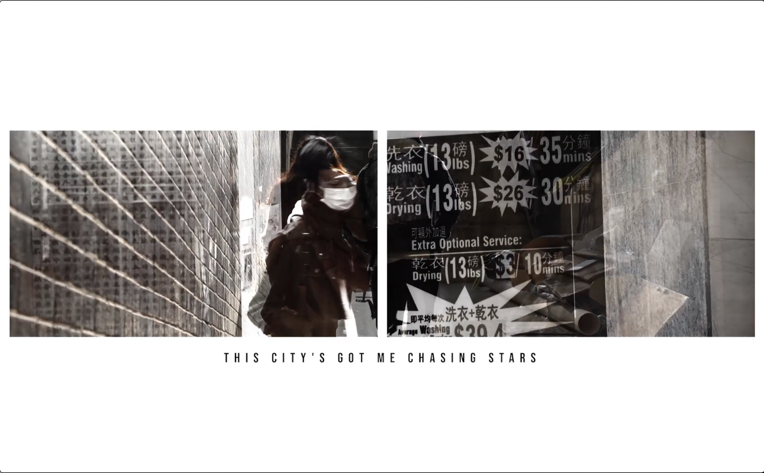 | Shot No. 18  Camera Movement :  Dolly Shot / Tracking shot  Type of Shot :  Medium Shot /Long Shot  Brief Description :  Boys walks alone in the city  Colour :  Colour | Verse 2– Sound  Guitar Accompaniment  Male Vocal  Lyrics :  Oh, this city's gonna break my heart  This city's gonna love me then leave me alone  This city's got me chasing stars It's been a couple months since I felt like I'm home
Edit/Length of Shot: 01:37 – 01:43
M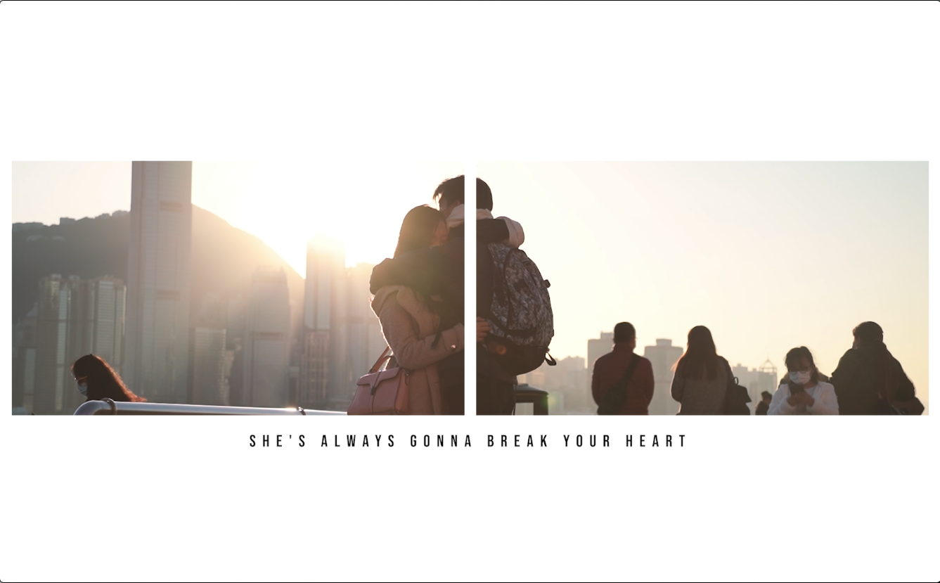 | Shot No. 19  Camera Movement :  Zoom  Type of Shot :  Medium -> Close up Shot  Brief Description :  Boys and girl hugs under the sun in the crowd  Colour :  Black and white to Colour | Verse 2– Sound  Guitar Accompaniment  Male Vocal  Lyrics :  Am I getting closer to knowing where I belong?  This city's gonna break my heart  She's always gonna break your heart  Crowd sound – diegetic sound
Edit/Length of Shot: 01:44 – 1:57

\

